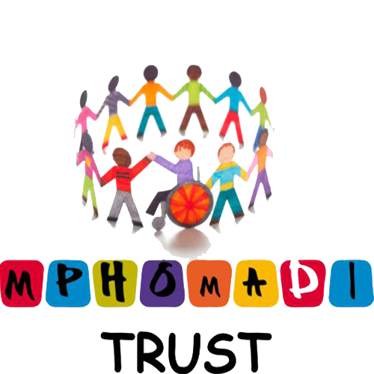
IT 13221/06
NPO 063-798

